For Chrome:
- In the browser bar, enter: chrome://settings/clearBrowserData. (See red box in the image below.)
- On the screen, a list of options with check boxes should appear. At the top, from the “Clear the following items from:” drop-down menu, you can choose the period of time for which you want to clear cached information. To clear your entire cache, select “the beginning of time”.
- From the list of check-boxes, select the following (see yellow box in the image below):
- Browsing history
- Download history
- Cached images and files
- Cookies and other site and plug-in data
- Select the “Clear Browsing Data” button. (See orange box in the image below.)
- Exit/quit all browser windows and re-open the browser.

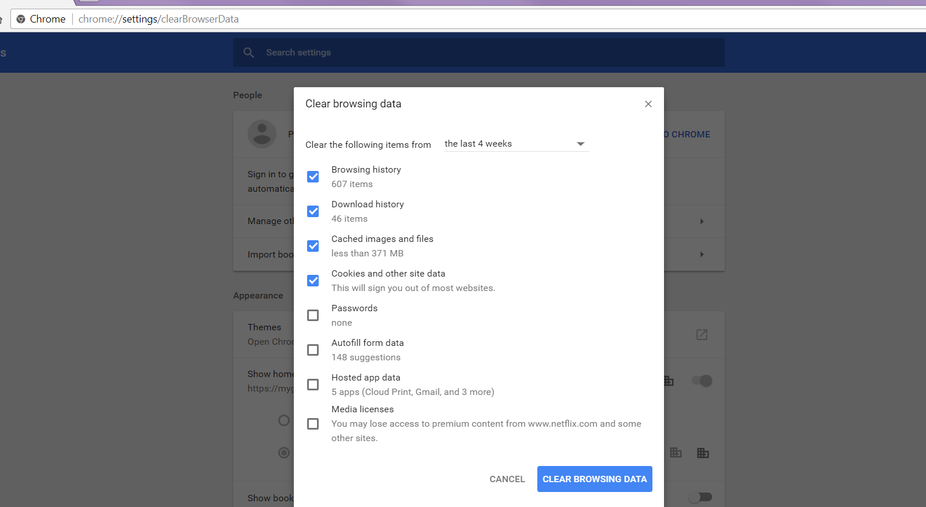

For Firefox:
- From the History tab in the browser menu (see yellow box in image below), select Clear Recent History (see red box in image below).
Tip: If the menu bar is hidden, press Alt to make it visible.
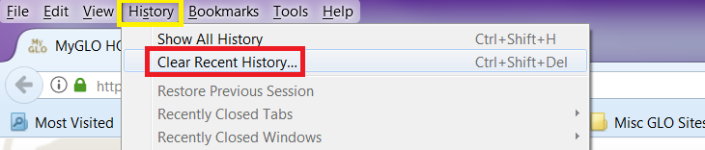

- From the “Time Range to Clear”: drop-down menu, select the desired range. To clear your entire cache, select “Everything”. (See red box in image below.)
- Next to "Details", click the down arrow to choose which elements of the history to clear. From the list of check-boxes, select the following (see yellow box in image below):
- Browsing & Download History
- Form & Search History
- Cookies
- Cache
- Click “Clear Now” button (see orange box in image below).
- Exit/quit all browser windows and re-open the browser.
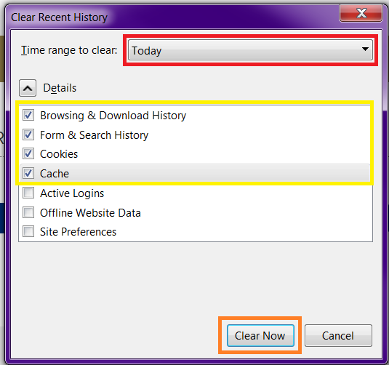

For IE 9 and higher:
- From the top right hand corner of the browser, select Tools (via the Gear Icon…see yellow box in image below) then Safety > Delete browsing history.... (see red box in image below).
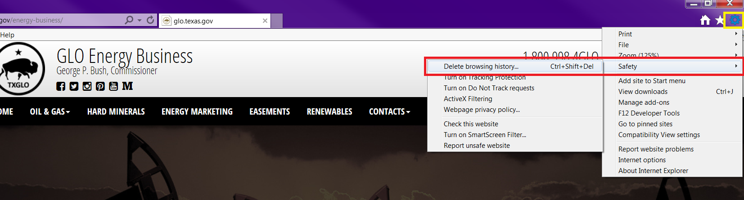

- Deselect Preserve Favorites website data, and select (see red box in image below):
- Temporary Internet files or Temporary Internet files and website files
- Cookies or Cookies and website data
- History
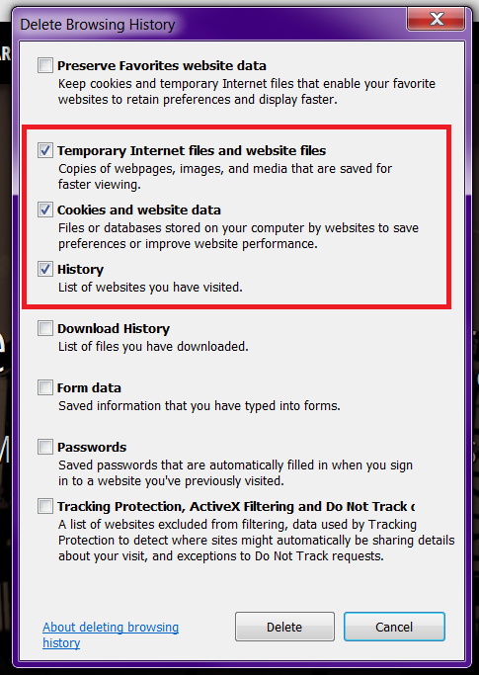

- Click Delete (see yellow box in image above). You will see a confirmation at the bottom of the window when the process is complete.
- Exit/quit all browser windows and re-open the browser.

For Microsoft Edge:
- In the Edge browser window, click on the 3-lined Hub button in the top right corner (see yellow box in image below).
- Next, select the clock-shaped History button (see orange box in image below).
- Click on “Clear all history” (see red box in image below).
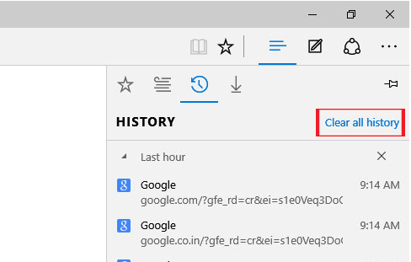

From here, you will be able to delete and clear your browsing History, Cookies, Data, Temporary Internet Files, Cache, etc.
- Select the following options (see red box in image below):
  - Browsing history
  - Cookies and saved website data
  - Cached data and files
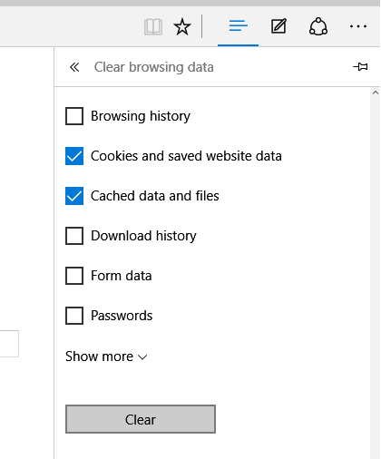

- Click the Clear button (see yellow box in image above). The message "All Clear!" will appear at the top when the data has been erased.

